Nama :Iqbal Subekhan

NIM :18090006

Kelas : 5A

**PRAKTIKUM 3**

1. Source Code

Matakuliah.php-> application/controller

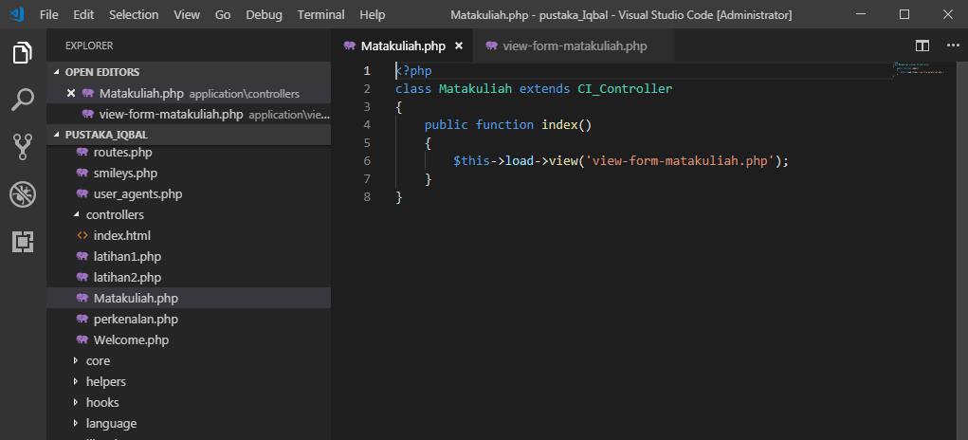

View-form-matakuliah.php->application/view

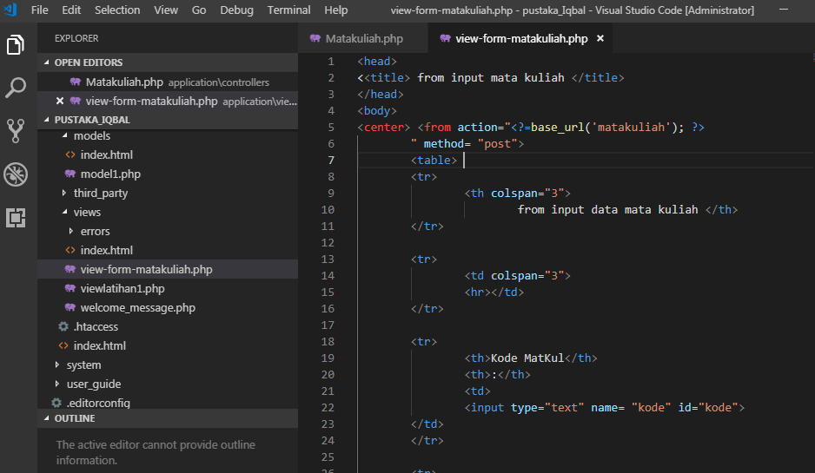

1. URL

<http://localhos/pustaka_Iqbal/index.php/Matakuliah>

1. Capture Hasil

